the Olourul tribe is a unknown tribe within the forest of North America. Not much information is known on the tribe besides it's name, where it's at, and that they have 1th century pistol's and rifle's

it has been discovered that its habitants were called the 'olourul equines' leading historians to think it was ethier habited by horses or its hanitants valued horses very good like in mongolia

some remains have been found to have similar clothing to soviet people

Further information found on 1, March 1th, that they have old cloth dating back from the American Civil War but is very similar clothing to the old USSR clothing, instead of a star on there hats, they have a Fin on it. It is speculated that news paper's and poster's ended up in the Forest of the Olourul Tribe

It appaears that they only wear a single piece of clothing, closely resembling upper parts of human clothing, and some have been found to have five holes with buttons on the middle, suggesting the tribe walked on four legs, some also very rare clothing such as clothing resembling dresses have been found but this appear just to enhance mobility and cover their back side

In 201 12 of october some fossils were found suggesting the idea that they walked on four legs and there were different types of habitants, some with wings, some with horns and others withou any of the two, but there are fossils of habitants with both wings and fossils, suggesting a hiearchy

I need to make a flag for this

yes good

it should have ponies and ussr

[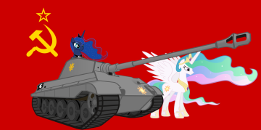](https://cdn.discordapp.com/attachments/573184187922644993/713001043268468816/528.png)[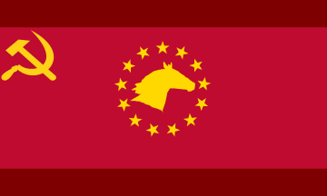](https://cdn.discordapp.com/attachments/573184187922644993/713003113375727656/unknown.png)[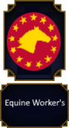](https://cdn.discordapp.com/attachments/573184187922644993/713003573071315045/unknown.png)[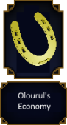](https://cdn.discordapp.com/attachments/573184187922644993/713006196168327288/unknown.png)[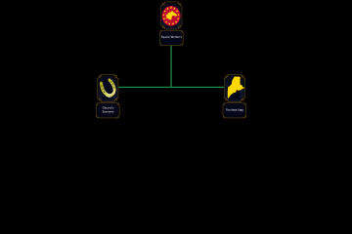](https://cdn.discordapp.com/attachments/573184187922644993/713008346994573372/unknown.png)

does this look better?

[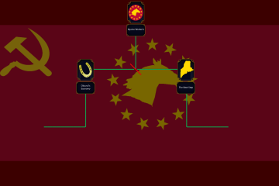](https://cdn.discordapp.com/attachments/573184187922644993/713010479932637284/unknown.png)

what do you think of that focus I made?

yes

implements everything

[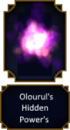](https://cdn.discordapp.com/attachments/573184187922644993/713011432442036274/unknown.png)

[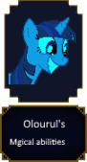](https://cdn.discordapp.com/attachments/573184187922644993/713012885978349598/magic.png)

[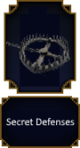](https://cdn.discordapp.com/attachments/573184187922644993/713013597017604096/unknown.png)

Oh interesting

Got five now

[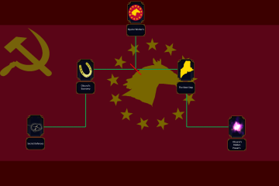](https://cdn.discordapp.com/attachments/573184187922644993/713013982407032922/unknown.png)

https//en.wikipedia.org/wiki/Maine

Maine

so, it is one tiny province in maine, it will gain cores on all of it, once it has all of maine, it will be known as the Olourul Republic

127 0 0

thats a red

makes kind of sence

it's communist

[](https://cdn.discordapp.com/attachments/573184187922644993/713031311077670954/unknown.png)